Dafen Art Museum, Wall, Public Sphere,
and Chinese Architecture as a Medium

Delin Lai, University of Louisville

(DRAFT – Please do not cite or circulate without permission of the author)

The Dafen Art Museum, designed by the URBANUS architects, is located at the center of Dafen Village in Longgang District of Shenzhen. The village has become famous in the past two decades for its duplications of world-famous oil paintings exported around the world. To portray a cultural image of the original agriculture settlement, the local government commissioned with an investment of nearly one hundred million RMB to build a museum. Having a total area of 16,000 square meters, the entire building consists of three levels, each with a special function. The first floor is connected to the plaza in the front, thus designed as a market for displaying and selling art works. Its second floor, which is accessible from the plaza through a long ramp, functions as the main gallery. The roof of the museum is intended to be a garden. While some of the “boxes” appearing on the roof are light wells of the gallery, others will be studios and cafeteria or tearooms by “lanes” that enable the local students and residents to pass by in their daily life (Fig. 1).
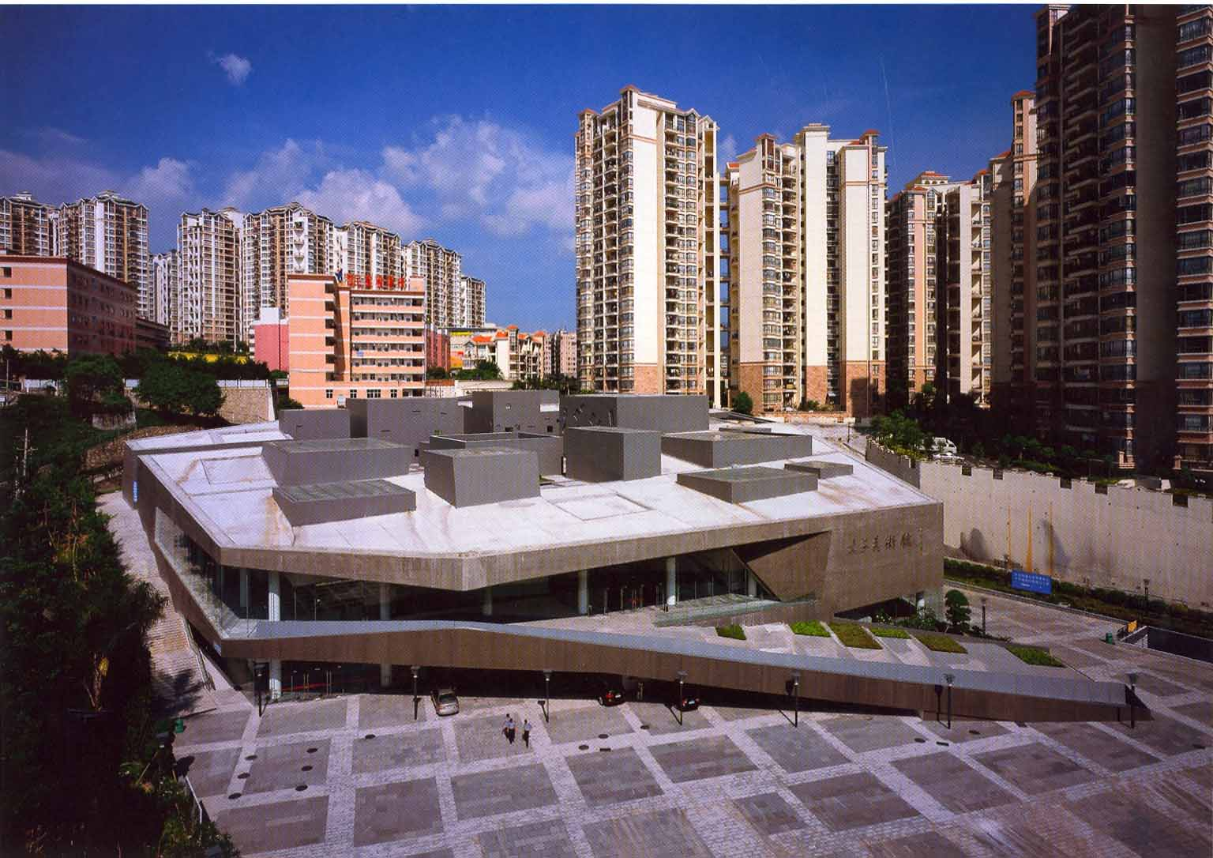

Fig.1 URBANUS: Dafen Art Museum, Shenzhen, 2007. Source: URBANUS, ed., URBANUS: Selected Projects, 1999-2007(Beijing: China Architecture and Building Industry Press, 2007): 125.

Since its completion in 2007, the Dafen Art Museum has received a number of awards, including the award of Best Architecture of China from the renowned American journals Business Week/China and Architectural Record in May 2008.

Besides its comprehensive functions, to me the design of museum’s exterior walls is also very creative and deserves the attentions of architectural critics. Visually, three walls of the museum show some tilted squares or rectangles (Fig. 2). According to the architect, these patterns came from the building lots on the original village map. Here they have become “frames” on the museum walls, which, as the designer expected, would allow local artists to display their works and add the final touch to the architectural design. In other words, the walls of the Dafen Art Museum were designed as a medium for local artists to express and exhibit themselves.
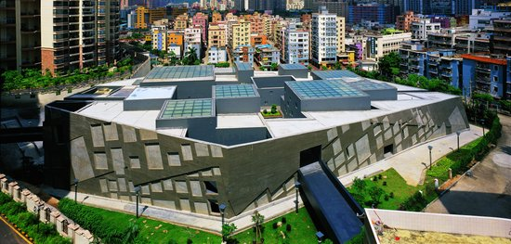
Fig.2 URBANUS: Dafen Art Museum, Shenzhen, 2007. Source: URBANUS, ed., URBANUS: Selected Projects, 1999-2007(Beijing: China Architecture and Building Industry Press, 2007): 120-121.

The design of these walls deserves attention because they are not merely boundaries between the interior and the exterior, and the gallery and the village, but also a medium of social significance. To understand it, we must first investigate modern Chinese visual culture in the context of China’s social development. More specifically, we must investigate how various social forces competed for the wall as a medium, a public sphere, and a spatial resource, and how they tried to control or appropriate it.

As in all cultures, the wall in China was basically a spatial boundary, as it was used to enclose a house compound, to define a neighborhood, to secure a city, or even to protect a country as in the case of the Great Wall. Unlike natural boundaries, such as mountains and rivers, the wall is a man-made structure, thus has artificial forms and surfaces which are associated with social concerns. For example, the Chinese philosopher Mozi of the fifth to fourth century BC said “the wall of a palace should be high enough to articulate the ritual of gender separation.” Chen Zhihua, a renowned Chinese architectural historian, has also noticed that the dwellings surrounded by high walls and the memorial arches in honor of chaste women co-existed in Huizhou area, which was famous for its commercial tradition in the Ming and Qing dynasties. He points out that this housing style was not only for concealing the wealth of local merchants, as previous scholars believed, but also for the segregation of their female family members from outsiders while they were away from home for their business (Fig.3). Today, “high wall” and “red wall” have become synonyms of power and rank in Chinese.

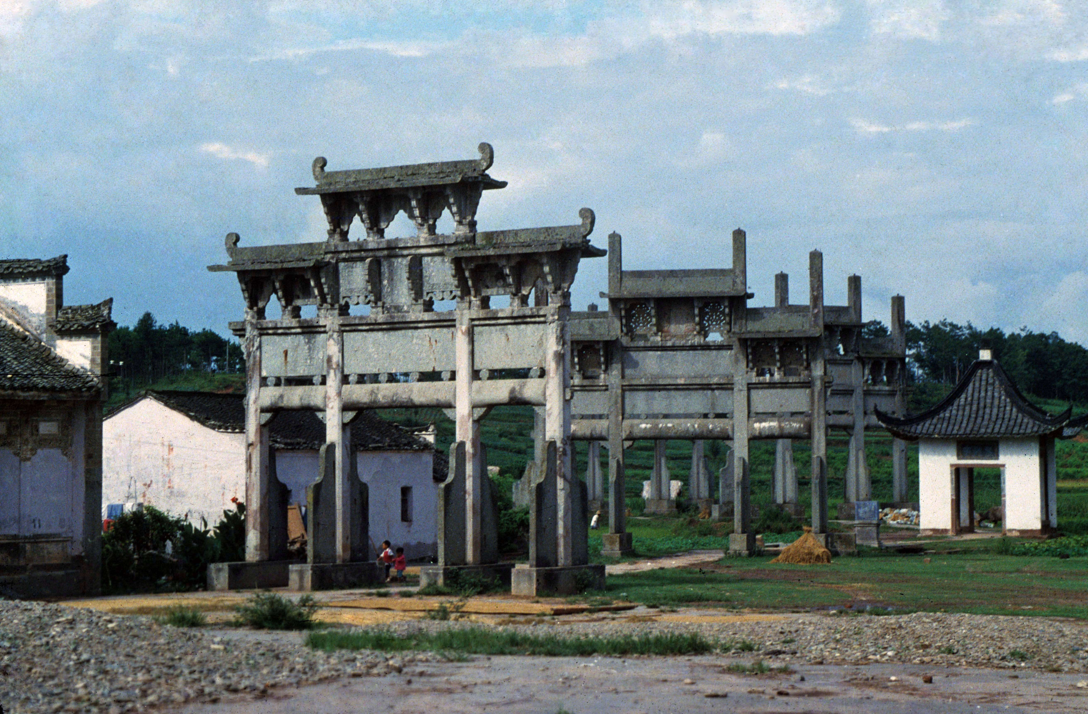
Fig.3 Memorial arches in Tangyue Village of Shexian County, Anhui province. Photo by the author, 1987.

Besides its function as a boundary, a wall also has a basic feature, namely, it has a flat surface that is visible. Just like a piece of paper or canvas, it can be used as a medium for expression or representation. In Chinese history there are numerous examples of walls being used for these purposes, and such famous stories as the Liang dynasty artist Zhang Sengyou adding the pupil of the eye as the finish touch to give life to a dragon he was painting, and the Tang dynasty poet Li Bai’s commenting that “Before my eyes are the beautiful scenery that I cannot say / As there are poems describing it by Cui Hao” are all wall-related. The art forms that combine with walls in China also include murals, brick carvings, stone carvings, and wall inscriptions. Zhaobi, the independent wall erected in front of a gate or entrance of a building compound or a settlement, was widely used for conveying social, cultural, even religious meanings. Decorated with iconic relieves or indexical words, zhaobi itself is a unique element of expression in Chinese architecture. Walter Benjamin says: “Distraction and concentration form polar opposites……This is most obvious with regard to buildings. Architecture has always represented the prototype of a work of art the reception of which is consummated by a collectivity in a state of distraction.” Wall associated art forms and other urban public art all share this characteristic.

The wall will inevitably encounter the state control after it becomes a medium and enters the public sphere. Most often, the walls in traditional Chinese architecture expressed nothing but the expectation for happiness, prosperity, and longevity, the admiration of the natural environment, and the propagation of Confucian ethnicity, or Buddhist, Daoist ideas. We can hardly imagine that the owners of those walls dared to express themselves through them, or their public images, anything negative to a society which was so developed in what Michel Foucault called “discipline and punishment.” A story in the chapter 39 of the Chinese classical novel Water Margin showcases the danger of an inadvertent use of a public wall. In the story, the famous outlaw Song Jiang composed two poems and inscribed them on a wall in a restaurant after getting drunk. These poems were later interpreted by another customer as Song’s manifestation of rebellion and were reported to the government. Song hence was arrested and almost killed had his outlaw friends not come and rescued him.

In modern China, walls have acquired a significance that is incomparable in any other historical periods. For instance, in the history of Sino-Western cultural exchange, the style of a wall has been an indication of cultural identity. In the discourse of nationalism, the Great Wall, a special wall of China, has stood for a symbol of the country. While in the art of revolution, walled mansions have been taken as the castle of Feudalist power. Created by Shi Lu in 1949, the woodblock print Down with the Feudalism, shows the peasant force floods into a landlord’s house guarded by layers of high walls, is a vivid illustration of the title (Fig.4). In the twentieth century, walls have also been the targets of China’s modernization as many cities tore down their fortifications for building wide, paved ring roads. This change, as Joseph W. Esherick says, “expressed as much as anything the triumph of a new discourse of economic development over old concerns for security, and a shift from controlling to facilitating the movement of goods and people.” It is not an exaggeration saying that in modern Chinese architectural history there is no other element that has such a wide socio-cultural association as the wall. In addition to the physical walls in visual culture, we also see metaphorical expressions in socio-politics, such as “iron curtain,” “bamboo curtain,” and the “Great Firewall” associated with internet censorship in China.

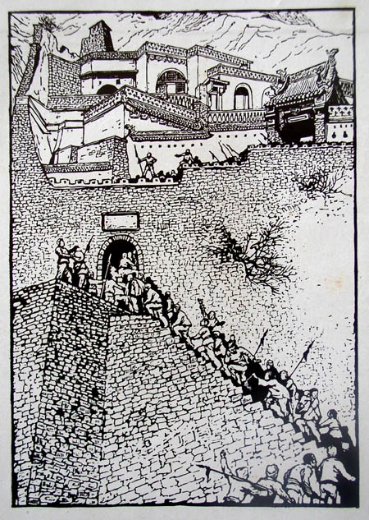

Fig. 4 Shi Lu: Down with the Feudalism, wood block print, 31.2 x 22cm, 1949. Source: Julia F. Andrews and Kuiyi Shen, A Century in Crisis: Tradition and Modernity in the Art of Twentieth Century China (New York: Solomon R. Guggenheim Museum, 1998), Figure 127.

Most of the revolutions that happened in modern China required the participation of masses. At the same time, they needed to educate people, mobilize people, and influence people. Methods for people’s easy access to political propaganda and its easy acceptance thus came into being, including slogans, wall paintings, posters, and even “big-character posters” that relied on walls as their medium. Compared to urban sculpture, an art form introduced to China from the West and made by professional artists, the wall associated art was much simpler and more convenient, and became the most wide-spread “public art” in modern China. Its fundamental goal was to turn a spatial resource into a political resource.

Being a political resource, the wall art had to face the intervention of politics. In 1938, the calligrapher Zhong Ling in Yan’an wrote a gigantic slogan “Workers and peasants united to win the war against the Japanese!” Since the character “workers” had fewer strokes in Chinese than “peasants” and appeared unbalanced in the slogan, he adopted a Han dynasty style by adding more strokes to the character. He could not have imagine that four years later during the Rectification Movement, which aimed to consolidate the communist ideology and the leadership of Mao Zedong, Mao made an important address, criticizing those cadres who worked without caring whom it was for. He used Zhong’s slogan as an example and said “this comrade is no doubt a student of ancient literati scholars, but it will be strange thinking he was writing on a wall specifically in Yan’an and during the war against the Japanese.” This famous story in modern Chinese art history suggested that, to the politicians, public art must be easily recognizable to the public, and any individual expression that failed to meet this requirement should not be encouraged.

After the establishment of the People’s Republic of China in 1949, more artists, both professional and amateur, were sent to the countryside to take part in slogan writing and mural painting. In early 1958, for instance, the renowned artist Gu Yuan and twenty five editors and artists of the People’s Art Publishing House went to Zunhua of the Hebei province and Gaoyou of the Jiangsu province to paint murals for local villages. Following the requirement of the Party Committee of Zunhua, Gu himself created several large wall paintings, which measured from a couple of meters to more than ten meters, as illustrations to the slogans of the Great Leap Forward Movement, such as “People of all gender and all age work together to achieve the goal of ten thousand jin per mu!” “Ten thousand jin of fertilizer, a thousand jin of weat!” “Each person feeds two and a half pigs, the whole county will have a million!” The government of Changli country of the Hebei province also organized a large group of artists consisted of 2,000 art teachers, local artisans, and art lovers. They created 65,000 wall paintings in a half month, making the county a famous “mural county” nationwide. One poem reveals the popularity and the social function of those paintings: “Socialist new murals, rooted in the new villages. Peasants love new murals and have them painting in each village. The cart of the Leap Forward, the horses of the Leap Forward, the painting of the Leap Forward is everywhere. The new mural is capable of speaking. They will educate people to open their hearts to the lighthouse.” The works of these artists and art lovers showcased the state occupation of public sphere in the countryside. These murals are not inside temple halls but on the exterior walls along streets, their contents are no longer religious deities or legends, but illustrations of the state policies. In both form and content they have revolutionized Chinese mural tradition (Fig.5).
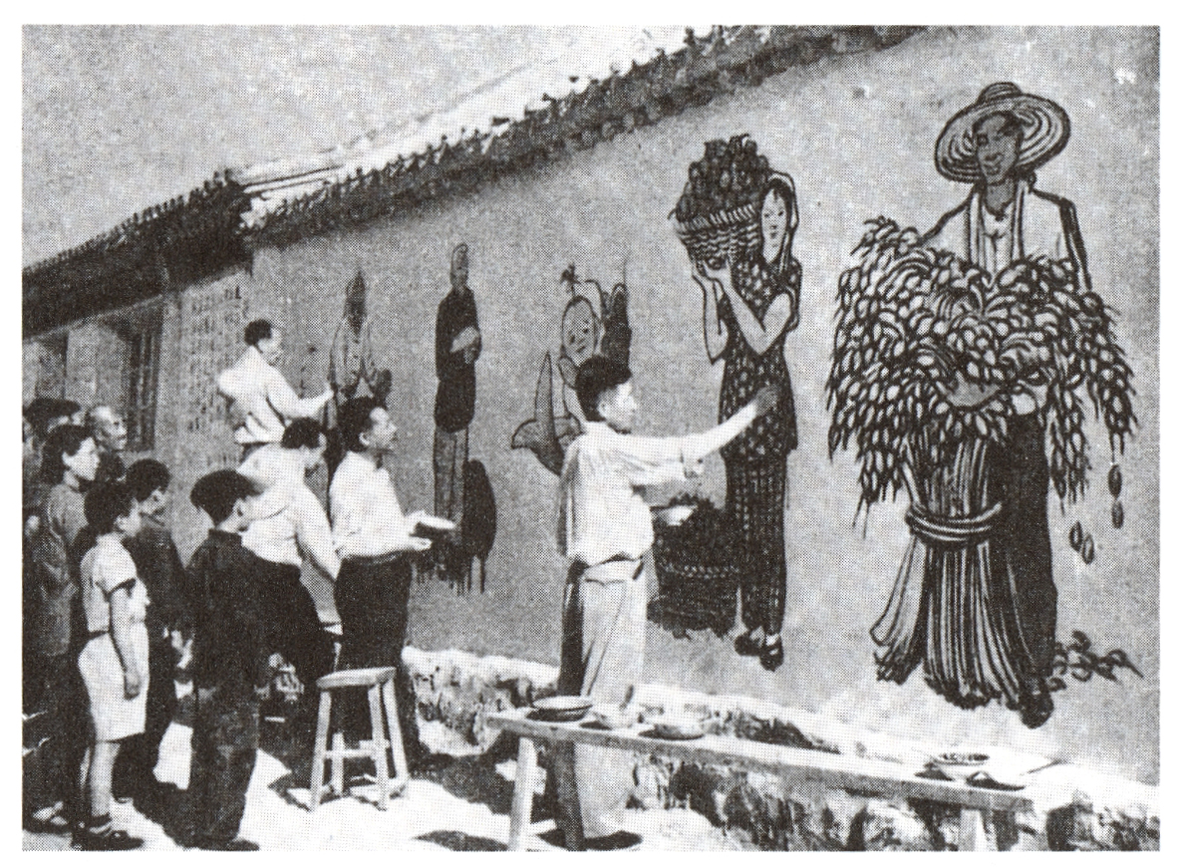

Fig.5 Shao Yu, Ye Qianyu, Wu Zuoren, and Jiang Zhaohe paint murals on a village wall in Hebei. Source: China Reconstructs (Nov. 1958), from Michael Sullivan, Art and Artists of Twentieth-Century China (Berkeley: University of California Press, 1996), Figure 14-2.

Dazibao, or the “big-character posters,” was another large scale appropriation of walls in modern Chinese history. It could be spread without government sanction, and not necessarily to conform to the official requirements, so could become a tool of free expression to the public. In order to be eye-catching, dazibao needed not only to be “big” in its form, but also to rely on public space, especially walls visible to the public. The popularization of dazibao might have been driven in 1957 by the campaign of “speaking out freely and airing views fully,” which was to promote pluralism of expression and criticism of the government. But its initiation can be traced back to the funeral of Sun Yat-sen in 1925 when people and civic groups posted numerous slogans and commemorative couplets on walls of Central Park in Beijing to lament the death of the founding father of the Republic of China (Fig.6). Obviously, the emergence of dazibao as a tool of expression and propaganda gained its popularity as the consequence of the increase of the role of public in political campaigns and movements.
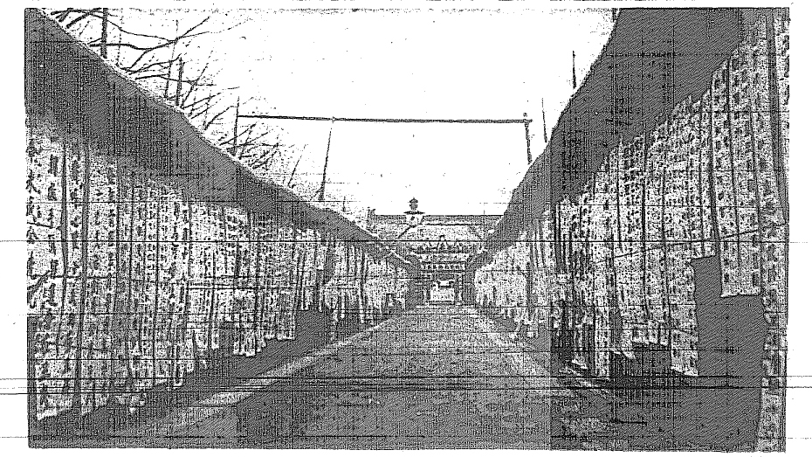
Fig.6 Commemoration couplets on walls of Central Park in Beijing, 1925. Source: Dongfang Zazhi, vol. 22, no.7, April 10, 1925, unpaged.

It is certain the booming and thriving period of dazibao came in the Cultural Revolution. On May 25, 1966, Nie Yuanzi, the Party Secretary of the Philosophy Department of Beijing University, and several of her colleagues posted on campus an article criticizing officials in charge of the colleague education in Beijing and the school authority (Fig.7). On June 1, Ma Zedong ordered it to be aired across the country. He later praised it as “the first Marxist dazibao,” and the “manifesto of Beijing Commune of the 1960s.” Mao himself also publish his famous “dazibao,” which was entitled “Bombard the headquarters: My first big character poster,” targeting “some “leader comrades in central or local governments” who were reluctant to support the Cultural Revolution. On August 9 he gave another instruction, requiring “a full use of big-character posts and big debates to facilitate free speaking and full view-airing.” With Mao’s support, dazibao soon spread over the country. Ultimately, in the first meeting of the Fifth National Congress, dazibao together with big debate, free speaking, and full view-airing were legalized by the newly passed constitutions as the “great socialist democracy” and “people’s democratic rights.”
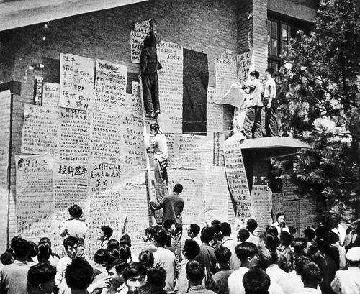

Fig.7 Big-character posts in Beijing University, July, 1967. Source: http://book.sina.com.cn/tushuogongheguo/excerpt/sz/2006-08-14/1611203702.shtml

Because of the support from the top leader, its mounting required no others’ permission. Dazibao made the wall a spatial resource and a public sphere most widely shared by the society during the Cultural Revolution. Soon after this period, this resource and sphere became the battle ground between the state ideology and unofficial voices. The fate of the “Xidan Democratic Wall” in Beijing showcased this fight. The wall measured about two meters high and roughly 200 meters long. It was located at the northeast corner of the cross between Chang’an Avenue, the east-west axis of Beijing, and the Xidan commercial street (Fig.8). Since November 1978, this wall has been used as a place for posting dazibao by people who intended to express their political views about China in the post-Mao era. A year later, in November 1979, the second meeting of the Fifth National Congress made a decision to ban this wall. On December 6, 1979, the Revolution Committee of Beijing notified the people, that except the writers’ working places, the only place for posting dazibao would be Yuetan Park, a small park in the west of Beijing, and all writers must file paper works with their true names and other identification information; dazibao at Xidan and elsewhere were prohibited. In February 1980, the Fifth Plenary Session of the Eleventh Central Committee concluded that rather than ensuring people a positive use of their democratic rights, dazibao as well as the big debate, free speaking, and full view-airing actually jeopardized these rights’ normal use. In September, deleting from the constitutions the article about the four people’s democratic rights became a resolution made by the third meeting of the Fifth National Congress. Consequently the wall lost its legitimacy as a medium for expressing public opinions.
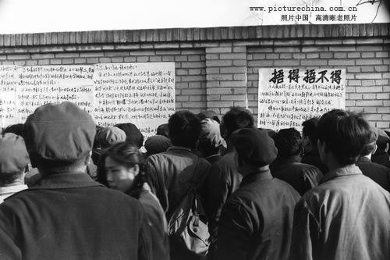

Fig.8 Didan Democratic Wall, Beijing, 1979. Source: http://www.picturechina.com.cn/bbs/。

Replacing dazibao to become popular in public sphere are two other wall-related art forms: wall posters and commercial advertisements. Similar to other forms of urban public art, both wall posters and commercial advertisements are assumably “consummated by a collectivity in a state of distraction” as well. Wall posters are images and words issued or sanctioned by the government. Their featuring in the public space of Chinese cities and countryside must not be later than those murals of 1958. During China’s reform era, the most famous official wall poster is unquestionably the gigantic portrait of Deng Xiaoping in Shenzhen erected by the Propaganda Department of the Shenzhen City Committee of the Communist Party in 1992 (Fig.9). The portrait, which was entitled “Insist on the Party’s Basic Line without Any Change in A Hundred Years,” is an independent wall with an area of 300 square meters. It is situated at a plaza of fourteen thousand square meters at the cross of Shennan Road and Hongling Road, two stern roads in the city. This wall continues the zhaobi tradition of Chinese architecture, highlighted the publicity and monumentality of the painting. More wall posters are erected along streets or against buildings. The government endorsement is often visible from the water-proof covers or roofs and lighting equipments, which will not only secure the posters but also ease its visibility.

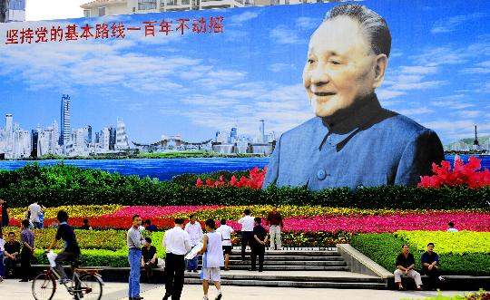

Fig.9 Plaza of Deng Xiaoping’s Portrait, Shenzhen, 1992-2004. Source: http://news.sina.com.cn/c/p/2008-10-19/212916483662.shtml

Commercial advertisements had been popular in Chinese cities in the early decades of the twentieth century. But since the 1950s, after the Socialist reforms of the capitalist industry and commerce, planed economy replaced market economy. Advertisement that was a market art by nature thus disappeared in Chinese public sphere. Substituting for it was various slogans (biaoyu), posters (haibao), and “propaganda paintings” (xuanchuanhua) with political connotations. Accompanying the open and reform in the late 1970s, as the Chinese market economy revived, so did the advertisement. On January 14, Ding Yunpeng, a young employee of the Shanghai Advertisement Company, published an article in Wenhuibao newspaper. The article, which was entitled “For rehabilitating the reputation of advertisement,” defended advertisement and soon echoed nation wide. Until today, historians still call it the “first horn of advertisement’s revive.” The popularization of advertisements relies on media. Besides broadcasting, TV, and the internet, the wall is another way for advertising. Wall advertisements hence become one of the most dominant forms of visual culture in contemporary Chinese cities. Its goal is to turn a spatial resource into a commercial one (Fig.10).
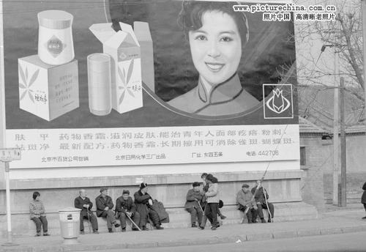

Fig.10 “The earliest and the biggest advertisement of female beauty, erected at a street cross in Shatan (of Beijing) in 1979.” Source: http://www.picturechina.com.cn/bbs/。

A phenomenon that fully reflects the fight for city walls is the extensive spreading of all kinds of “little advertisements” (xiaoguanggao), which people vividly call the “urban eczema” (Fig.11). These little advertisements are mostly related to illegal business and activities, such as seal and identification forgery, “receipt” purchasing, and “companion” seeking. Their existence which can almost be described as everywhere not only disfigures the urban environment, but also causes damages to public facilities. But it is strange that now only sanitation workers are responsible for scraping and cleaning the contaminated surfaces over and over again, whereas few law enforcement agencies have tried to chase the origins of these advertisements simply according to the given contact information and to root them out. The government’s attitude toward the little advertisement seems distinctive from that toward the “reactionary slogans” (fandong biaoyu).

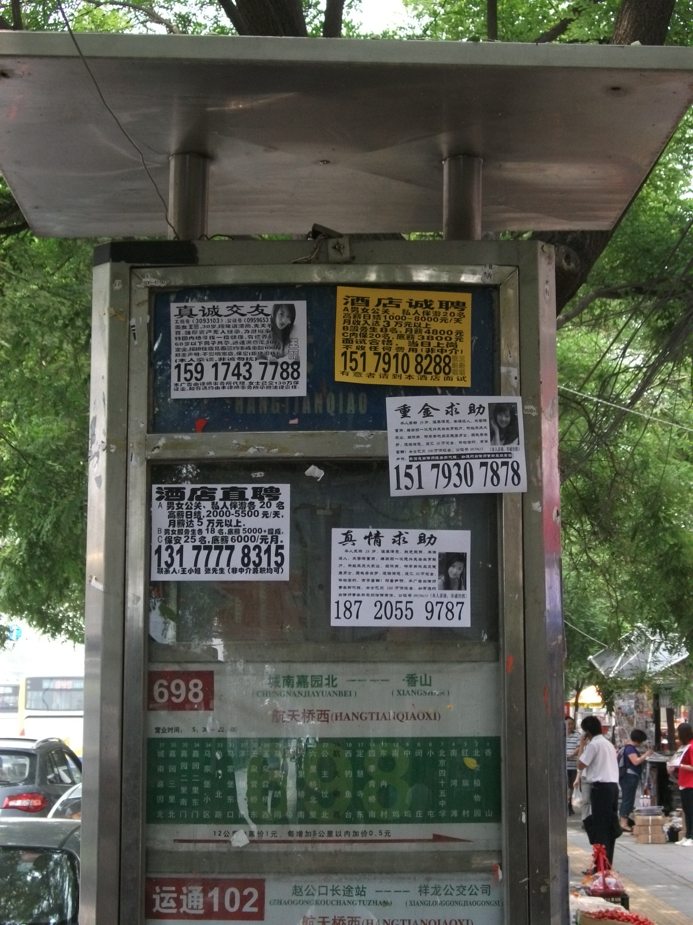

Fig.11 A bus station with “little advertisements” in Beijing. Source: photo by the author, 2010.

Since the 1990s, the wall has also witnessed the battles for urban space in the booming of China’s real estate development. The tearing down of Beijing University’s south wall in March 1993 is a famous example. When the school authority decided to open the south wall of the school for making a commercial street with a shopping area of 25,000 square meters, one young student vehemently opposed and said: “This is a big tragedy. From now on Beijing University will not be able to produce a pure scholar.” But the associate party secretary who was in charge of the real estate development of the school argued that tearing down the wall indicated the renew of school’s guiding principles. Some media commented, “Whether people want or not, the concept of ‘ivory tower’ has disappeared here. The people of Beijing University who used to be known as academic and political oriented are now tied together with economy.” The newspaper Wenhuibao also asserted: “Beijing University is not saying goodbye to a wall but to an era of wall.” To an architectural and urban historian, the story of Beijing University repeated the history of the capital Bianliang in the Song dynasty when the enclosed neighborhoods inherited from the Sui and the Tang dynasties were opened up to facilitate commercial activities, which in turn resulted in the formation of commercial streets.

Symbolically, a contemporary Chinese art also emerged from the fight for the wall—an exhibition medium. In 1979, after a group of avant-garde artists were rejected by the National Gallery to exhibit their works, they held their own show, which was called “Xingxing Exhibition,” by displaying their works on the gallery fence. “Xingxing” literarily means stars, but it also means sparks, as it was once used in a poem of Mao Zedong, which reads “a tiny spark can set the steppes ablaze.” It is by this latter meaning, I believe, that those artists named their exhibition (Fig.12). Indeed, the history not only proves the successful spreading of Chinese experimental art, but also shows the reappearance of the wall as an important subject matter of those artists. For example, Xu Bing’s work “Ghost beating the wall” is an ink rubbing of a section of the Great Wall. The rubbing turns a massive wall into a flat sheet of paper, an exterior structure into an interior installation of ink and paper, and a national symbol into a private collection. Ultimately it deconstructs the monumentality of the Great Wall and reveals its oppression to people. The artist Song Dong lives by a high wall surrounding a high official’s mansion inside. The wall not only symbolizes the official’s rank, but also conceals all his secrets and helps create his myth. Using the idea of “silk bag,” which in classical Chinese literature referred to the wrapping of a secret document, Song hangs many bags containing ice on the high wall and names his installation “Leaking Secrets.” When the curious people find the secrets leaking out are nothing but water, they would snicker at the seemingly mysterious wall (Fig.13).
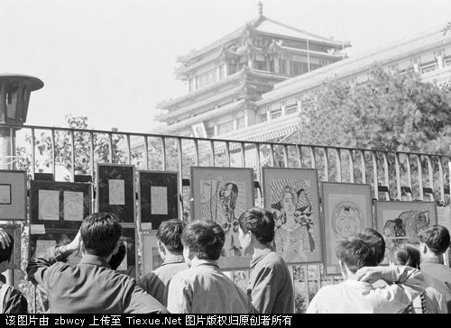

Fig.12 Xingxing Exhibition outside the National Gallery, September 1979. Source:http://www.picturechina.com.cn/bbs/。

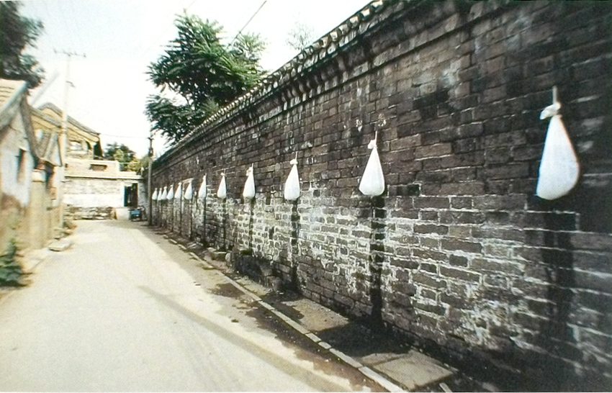

Fig.13 Song Dong: Leaking Secretes, 1995, installation, Beijing. Source: Wu Hung, Transience: Chinese Experimental Art at the End of the Twentieth Century (Chicago: University of Chicago Press, 1999), 46。

During the current real estate development in Chinese cities, walls have become a battle ground in which the government, the developers, and the resident confront with each other. It has also become an important element in contemporary Chinese art. The artist Zhan Wang carefully painted a demolished building, just like putting makeup on a deceased relative in order to let her die with beauty and dignity (Fig.14 ). Another Beijing artist Zhang Dali said: “Many things are happening in this city: demolition, construction, car accidents, sex, drunkenness, and violence infiltrates every hole....I choose these walls. They are the screen onto which the show of the city is projected.” His series “graffiti” works sketched on numerous walls in Beijing documented his dialogue with this city. Huang Rui’s photographic works featured various demolished neighborhoods. He entitled them “Chi-na,” which pronounced the same as “demolishing” in Chinese. The title and the works thus becomes his protest against a violent state (Fig.15)
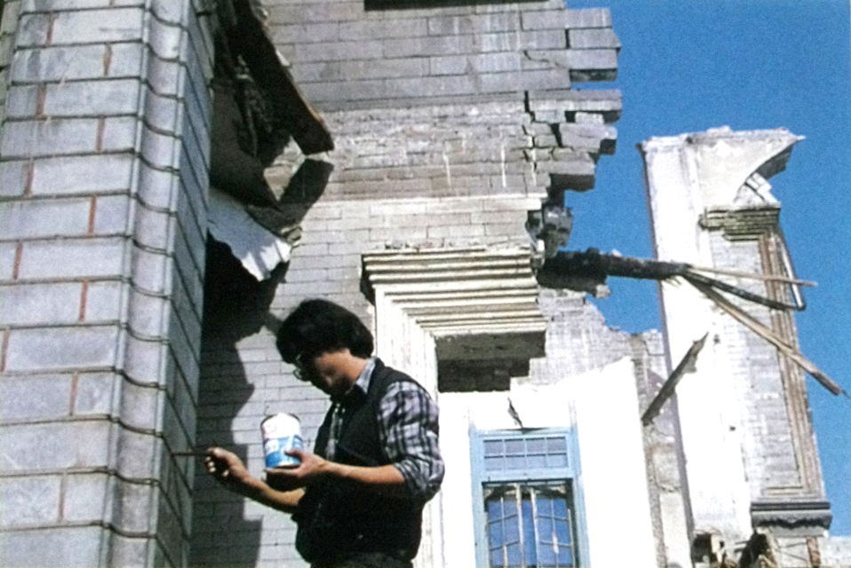

Fig.14 Zhan Wang: Cleaning a ruined site, 1994, performance art, Beijing. Source: Wu Hung, Transience: Chinese Experimental Art at the End of the Twentieth Century (Chicago: University of Chicago Press, 1999), 112.

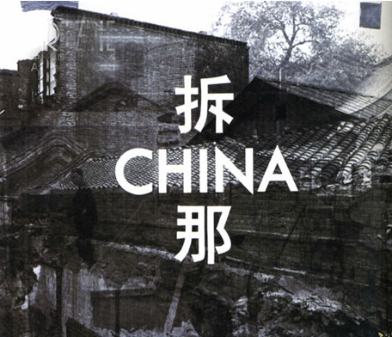

Fig. 15 Huang Rui: Chi-na/Destructing, 2007. Source:http://www.qhmy798.com/display.php?id=54

In modern Chinese architectural history, the wall has been used by many public building as a medium of expression. Rather than through symbolic sculpture and indexical word as did traditional architecture, the meanings of twentieth century China are expressed through the symbolic elements of different styles, such as Chinese style, Modernist style, Post-modern style, and “European style.” Each style represents a cultural ideal the patron is seeking. It should also be noted that this cultural ideal is not limited to the stylistic choice made in the design of a building, but also reflected in the “façade change” after its completion. “Façade change” is a widely used method in contemporary Chinese architectural and urban renewal movement. It enables the owner to adjust his/her taste, and without changing the original structure to acquire a new building that can meet the new aesthetic expectation. The urban authority, one the other hand, can also resort to façade change for a desired city image.

In Chinese architectural design of recent years, two theories, both introduced to China from the West, have affected the making of a wall significantly. One theory disregards the applied meaning of architecture in favor of “tectonic” qualities of the structural elements and materials. The other believes the surface, or the “skin” of a building is independent of the structure and has its own logic. Although both theories hold different attitudes toward the issue of architectural expression, they insist the autonomy of architecture and the architect’s independence in his/her design. To these architects, the changes by others on a design are unacceptable, and the best situation of a building is (not) after its completion but before it is used.

The walls of the Dafen Art Museum exhibit the abstract characteristics of a two dimensional composition rather than the sculptural quality through the contrast between light and shadow. The square or rectangular frames provide walls with an order. But their tilted arrangement and verified sizes also render the walls with randomness and contingency (Fig.16). As the architects expected, these walls would be a sphere, which was sanctioned by the government to allow the public, the architects, and local artists to communicate. It demonstrates the openness of the village as well as the government. In Different from both “tectonic” and “surface” approaches to an architecture, the museum would be a medium, while the architects have expressed themselves through it, they also invite the owner and the public to express.

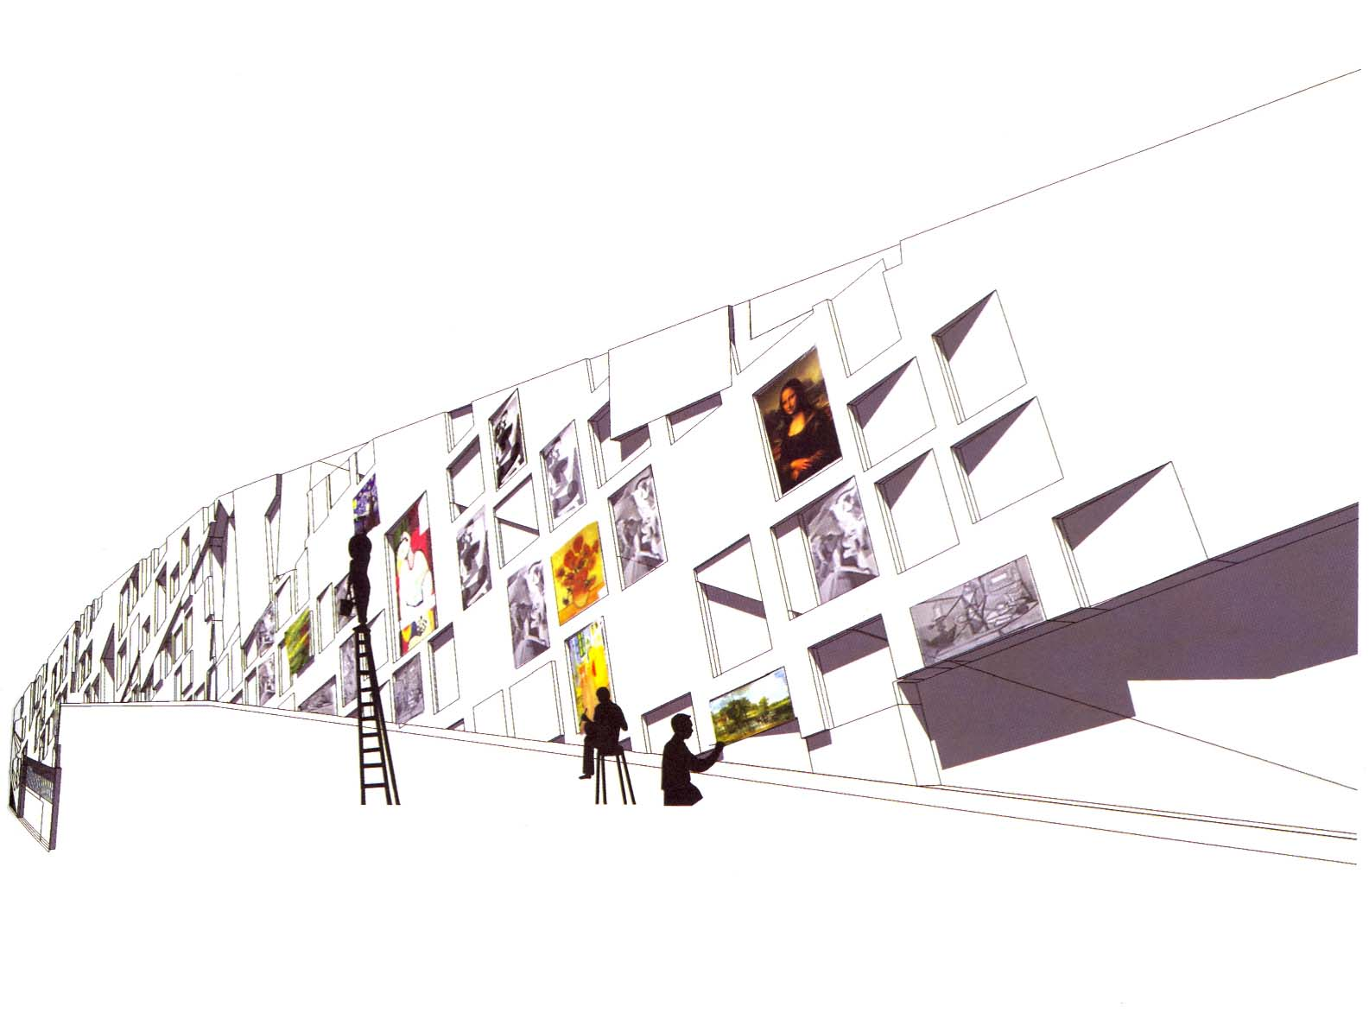
Fig.16 URBANUS: Dafen Art Museum, Shenzhen, 2007. Source: URBANUS, ed., URBANUS: Selected Projects, 1999-2007(Beijing: China Architecture and Building Industry Press, 2007): 124。

The construction of the Dafen Art Museum has been completed for more than two years. But the architects’ expectation for local artists to display their works on the museum’s exterior walls remains unrealized. What has been done in these two years is a 810-square-meter relief carved on the retaining wall by the museum plaza (Fig.17). The relief was commissioned by the local government with an investment of five million RMB. Entitled “A history of Western art,” it shows in relief form classical pieces from Greco-Roman period to the Cubism and Fauvism of the early twentieth century. This is a narrative of Western art permitted by the Chinese educational authority and applied in the teaching of state-run art schools. The permanence of its material, the monumentality of its scale, the formality of those art works’ arrangement, and even the symbolism of the red color, will form a sharp contrast with the paintings to be hung on the walls of the museum. No matter whether the will of the architects can be realized, I believe, this museum has become a touchstone. It has tested and will continue to test the openness of a civil society. It will also force people to think, in terms of a medium and a spatial resource, how will the wall of a city be used and by whom?

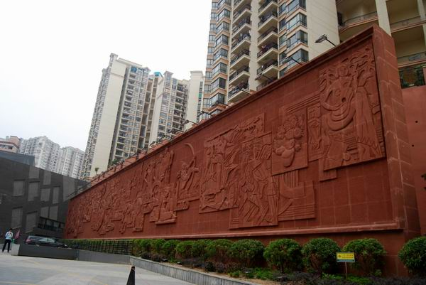

Fig.17 Shenzhen Guangmei Sculpture and Mural Art Co. Ltd.:“A History of Art,” plaza of Dafen Art Museum, Shenzhen, 2008. Source: Photo by Zhang Yun, August, 2010.

My interview with the main designer Meng Yan on May 21, 2008.
陈志华：〈难了乡土情——村落·博物馆·图书馆〉，《建筑师》，第59期，1994年8月。页47-55。
Walter Benjamin: “The Work of Art in the Age of Mechanical Reproduction,” 1936.
Waldron, Arthur: “The Great Wall Myth: Its Origins and Role in Modern China,” The Yale Journal of Criticism 2, no.1 (1988): 67-104.
Esherick, Joseph W.: “Modernity and Nation in the Chinese City,” in Esherick, Joseph W. (ed.), Remaking the Chinese City: Modernity and National Identity, 1900-1950 (Honolulu: University of Hawaii Press, 2000): 7.
孟红：〈钟灵：一个与新中国开国大事相关联的人〉（2009年10月23日），中国共产党新闻网（http://dangshi.people.com.cn/GB/85038/10246007.html）
廖国柱：〈大跃进时期的新壁画与宣传画〉（2008年3月24日），博宝艺术网（http://news.artxun.com/bihua-698-3488704.shtml）；姜维朴：〈1958年遵化县黎河美术学校的往事〉，《中国美术馆》，2007年第1期。
陈履生：《新中国美术图史》（北京：中国青年出版社，2000年）。
这些壁画在当时被称为「新壁画」，见力群：〈新壁画的出现是一件大事〉，《美术》，1958年，第8期。转引自陈履生：《新中国美术图史》，65页。
罗平汉：〈不寒而栗的历史——大字报在中国的兴衰〉（2007年3月28日），Sina新浪论坛，（http://forum.book.sina.com.cn/thread-1543266-1-592.html）；胡绩伟：〈胡耀邦与西单民主墙〉（2004年4月19日），「看中国」网，http://www.kanzhongguo.com/node/64125
宋毅、周敏、薛世君：〈深圳邓小平画像广场换新画像〉（2004年8月16日），新华网，http://news.xinhuanet.com/newscenter/2004-08/16/content_1797271.htm
本刊编辑部：〈中国广告大门徐徐打开〉，《小康》，2008年第10期。
2007年7月31日，即第29届奥林匹克运动会开幕之前一年，北京石景山区民防局与区08环境办曾联合举办老山奥运场馆群外围保障工作实战演练，「拆除反动标语」 就是六个演练科目之一。演练照片显示一位头戴钢盔的防暴警察正在一个由警察保护的「作案现场」扭送一位看似「反动标语」张贴者的戴眼镜年轻人。石景山区防空防灾网，http://minfangju.bjsjs.gov.cn/gzdt/8a8481cb1415559801141f1d6cd50010.html
王佳航：〈北大为何推倒商业街重树南墙〉（2001年7月16日），上海科技网，http://www.stcsm.gov.cn/detail/detail.aspx?tbno=202&id=6004
Wu Hung, Transience: Chinese Experimental Art at the End of the Twentieth Century (Chicago: University of Chicago Press, 1999), 31-34.
Wu Hung, Making History: Wu Hung on Contemporary Chinese Art (Hong Kong: Timezone 8, 2009), 47-57.
立面改造的对象大多是20世纪80年代之前纯粹「功能主义」的建筑，但也不排除一些并不久远和并非寻常的设计，如最近清华大学建筑学院就计划在2011年百年校庆之前改造由原建筑学院院长胡绍学设计、1996年落成的建筑馆的立面。见〈清华建筑馆立面改造方案征集〉，清华大学建筑学院网，http://arch.tsinghua.edu.cn/gz/
〈历史名人「栩栩如生」演绎西方《美术史话》〉，《深圳商报》，2008年5月15日。

